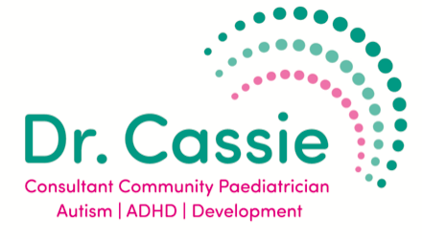
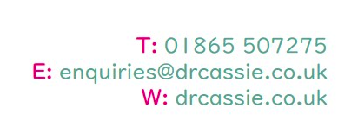

Information for parents of children who have been prescribed Methylphenidate

Your child has been given a prescription for medication containing methylphenidate. Methylphenidate is used to treat ADHD and is available in two main forms:

Short-acting methylphenidate: Short acting preparations last for 3-4 hours and the effect then wears off. They can be taken several times a day, but the final dose should not be taken any later than 5pm as it can cause difficulty sleeping.

Long-acting methylphenidate: Long-acting preparations last for a longer period of time and are therefore just taken once a day, in the morning.

Brand names of medication containing long-acting methylphenidate include:

Equasym XL — lasts for around 6-8 hours
Medikinet XL — lasts for around 6-8 hours
Concerta XL — lasts for around 10-12 hours

You will be given a small dose of medication to start with and may need to increase this gradually, depending on the advice given to you by Dr Cassie
Some children/young people may experience side-effects from the medication.

The commonest side-effects include:
- Nervousness and difficulty sleeping
- Reduced appetite
- Stomach pains, nausea, dry mouth
- Headache, drowsiness, dizziness
- Palpitations
- Anxiety, irritability

Side-effects usually settle down if you continue with the medication but if they are severe or you are concerned, please contact Dr Cassie to discuss this.

It is important to have your blood pressure, heart rate, height and weight monitored while on methylphenidate. We will check these before your child starts medication and at regular intervals while on medication.

